**Software Development Project**

**User Stories**

**Smart Fitness Tracker APP**

**Team 7**

**Maganbet Abdymomunov - 301253434**

**Jijo George - 301429225**

**Muskaan Sharma - 301435941**

**1. Introduction**

The Smart Fitness Tracker App is designed to enhance fitness tracking, goal setting, and communication between users and coaches. The app also includes administrative and developer functionalities to ensure seamless operation and management. This report presents user stories for each role, a low-fidelity prototype, and an evaluation of story estimation.

**2. User Roles and Stories**

**2.1 User**

**As a user I want to register, sign in using email account and password**

• **As a user, I want to create a profile so that I can store my personal details.**

• **As a user, I want to track my fitness progress so that I can monitor my improvements.**

• **As a user, I want to receive personalized AI-based fitness recommendations so that I can achieve my fitness goals efficiently.**

• **As a user, I want to sync my wearable devices so that I can get real-time updates on my fitness activities.**

• **As a user, I want to manage my personal stats so that I can update my progress as needed.**

**2.2 Coach**

• **As a coach, I want to send reminders to users so that they stay consistent with their fitness plans.**

• **As a coach, I want to chat with users so that I can provide guidance and motivation.**

• **As a coach, I want to track my clients’ progress so that I can adjust their workout and diet plans.**

• **As a coach, I want to set personalized workout plans so that users can achieve their fitness goals effectively.**

**2.3 Admin**

• **As an admin, I want to manage user accounts so that I can ensure the proper use of the app.**

• **As an admin, I want to handle subscription plans so that users can access premium features.**

• **As an admin, I want to generate reports on app performance so that I can analyzeuser engagement and detect potential issues.**

• **As an admin, I want to monitor security and login activities so that I can prevent unauthorized access.**

**2.4 Developer**

• **As a developer, I want to fix reported bugs so that the app remains functional and reliable.**

• **As a developer, I want to release feature updates so that users can enjoy new functionalities.**

• **As a developer, I want to monitor and improve app performance so that it runs smoothly without crashes.**

**3. Low-Fidelity Prototype**

A consolidated low-fidelity prototype has been created, representing the structure and navigation flow of the application. Each module has been labeled appropriately to correspond with the user roles  
  
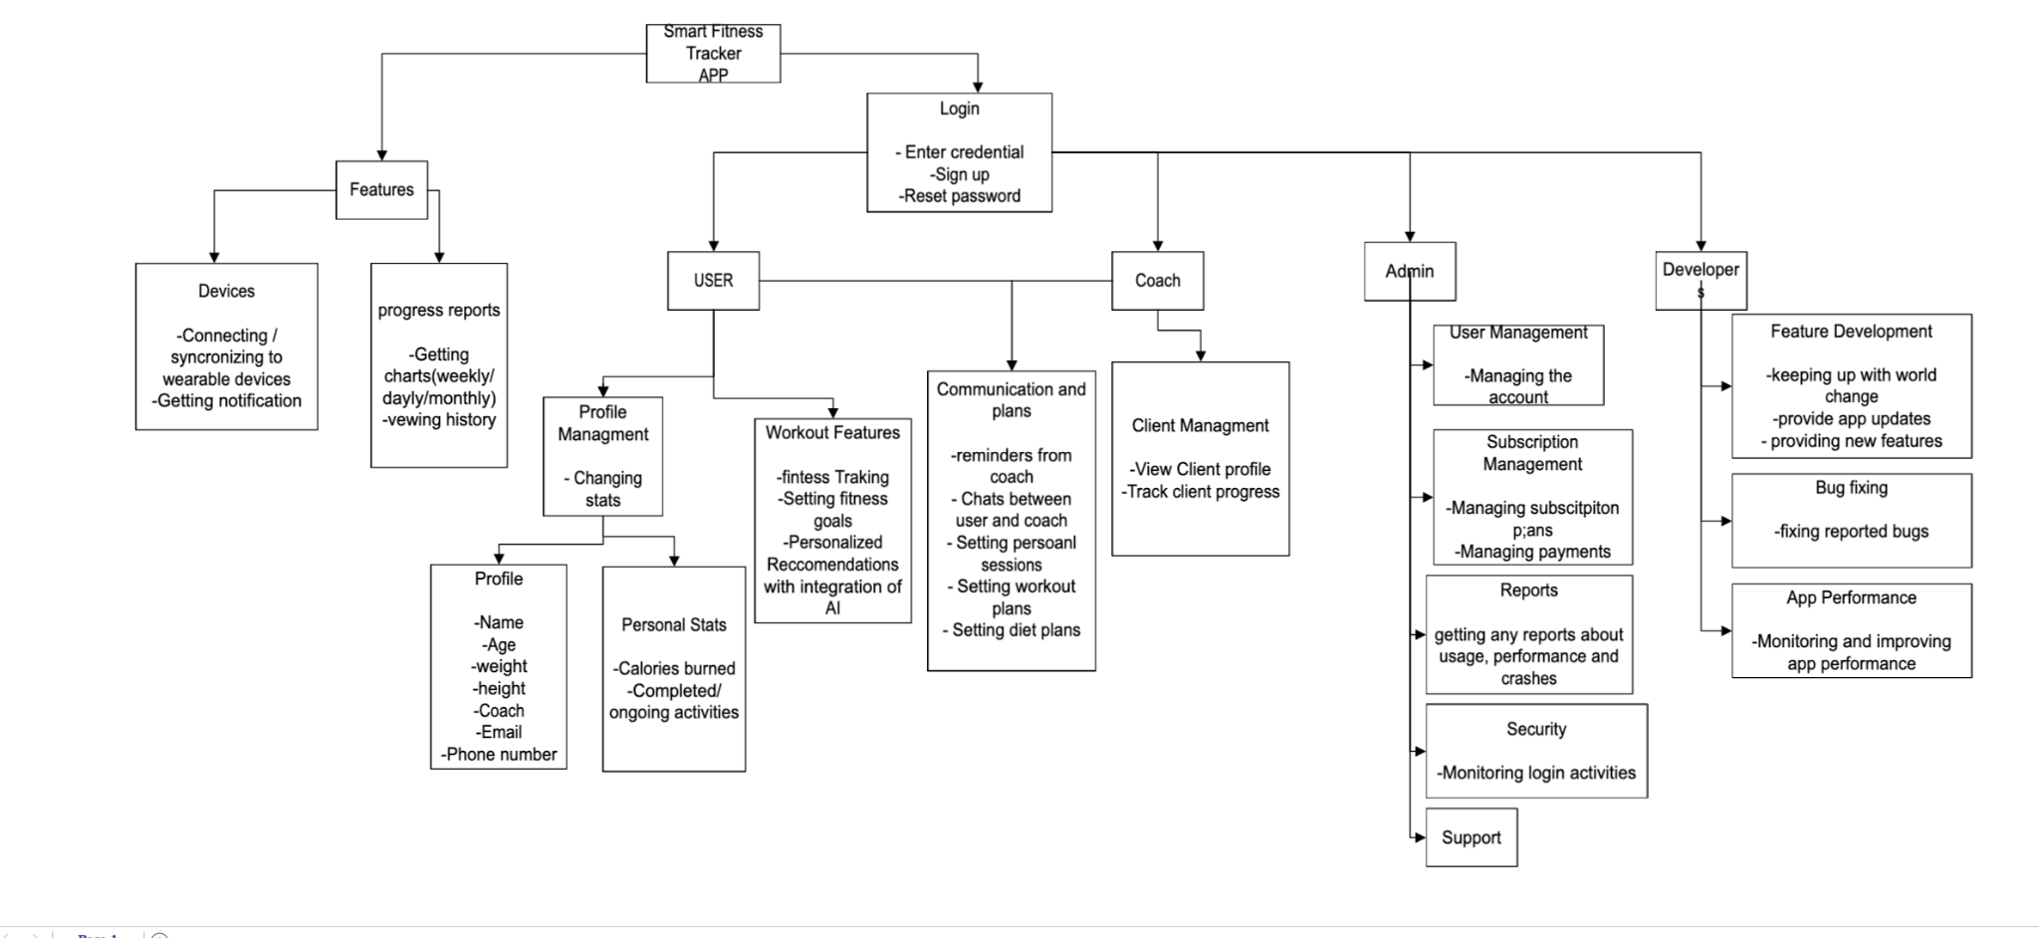  
  
**Wideband Delphi approach**

1. User story: **As a user I want to register, sign in using email account and password**

Acceptance test:

* The system should validate unique emails during registration.
* Users should receive a confirmation email upon registration.
* Users should be able to sign in with valid credentials.
* Incorrect login attempts should display an error message.
* Account lockout should occur after multiple failed attempts.

Story estimate:

| Team Members | Story points |
| --- | --- |
| Developer 1 | 6 |
| Developer 2 | 3 |
| Product owner | 3 |

**TOTAL:5**

1. User Story: **As a user, I want to create a profile so that I can store my personal details.**

Acceptance test:

* Users should be able to enter their name, age, weight, height, and email.
* The system should validate required fields and prevent submission with missing data.
* Users should be able to update or edit their profile details.
* Profile data should be securely stored in the database.

| Team Members | Story points |
| --- | --- |
| Developer 1 | 3 |
| Developer 2 | 4 |
| Product owner | 3 |

**TOTAL:4**

1. User Story: **As a user, I want to track my fitness progress so that I can monitor my improvements.**

Acceptance test:

* Users should be able to log workout activities.
* System should generate progress reports.
* Progress should be visualized using graphs and statistics.

| Team Members | Story points |
| --- | --- |
| Developer 1 | 4 |
| Developer 2 | 5 |
| Product owner | 3 |

**TOTAL:4**

1. User Story: **As a user, I want to receive personalized AI-based fitness recommendations so that I can achieve my fitness goals efficiently.**

Acceptance test:

* AI should analyze workout history to provide suggestions.
* Recommendations should be tailored based on user goals

| Team Members | Story points |
| --- | --- |
| Developer 1 | 6 |
| Developer 2 | 7 |
| Product owner | 5 |

**TOTAL:6**

1. User Story: **As a user, I want to sync my wearable devices so that I can get real-time updates on my fitness activities**

Acceptance test:

* The system should automatically sync data with connected wearable devices.
* Users should be able to manually refresh data.
* The latest data should be visible on all logged-in devices.

| Team Members | Story points |
| --- | --- |
| Developer 1 | 3 |
| Developer 2 | 5 |
| Product owner | 3 |

**TOTAL:4**

1. User Story: **As a user, I want to manage my personal stats so that I can update my progress as needed.**

Acceptance test:

* Coaches should be able to schedule workout reminders.
* Users should receive notifications for upcoming workouts.
* Users should have the option to reschedule reminders.

| Team Members | Story points |
| --- | --- |
| Developer 1 | 3 |
| Developer 2 | 4 |
| Product owner | 3 |

**TOTAL:4**

1. User Story: **As a coach, I want to send reminders to users so that they stay consistent with their fitness plans.**

Acceptance test:

* Coaches should be able to schedule workout reminders.
* Users should receive notifications for upcoming workouts.
* Users should have the option to reschedule reminders.

| Team Members | Story points |
| --- | --- |
| Developer 1 | 3 |
| Developer 2 | 4 |
| Product owner | 3 |

**TOTAL: 4**

1. User Story: **As a coach, I want to chat with users so that I can provide guidance and motivation.**

Acceptance test:

* Coaches should be able to send and receive messages from users.
* Users should be able to reply to messages in real-time.
* The system should support message history storage.
* Notifications should be sent for unread messages.

| Team Members | Story points |
| --- | --- |
| Developer 1 | 5 |
| Developer 2 | 6 |
| Product owner | 4 |

**TOTAL:5**

1. User Story: **As a coach, I want to track my clients’ progress so that I can adjust their workout and diet plans.**

Acceptance test:

* Coaches should be able to view client progress reports.
* The system should allow tracking of workout and dietary changes.
* Clients should receive progress feedback and updates.

| Team Members | Story points |
| --- | --- |
| Developer 1 | 4 |
| Developer 2 | 5 |
| Product owner | 3 |

**TOTAL:4**

1. User Story: **As a coach, I want to set personalized workout plans so that users can achieve their fitness goals effectively.**

Acceptance test:

* Coaches should be able to create and assign personalized workout plans.
* Users should receive notifications when a new plan is assigned.
* The system should track user adherence to the workout plan.

| Team Members | Story points |
| --- | --- |
| Developer 1 | 5 |
| Developer 2 | 6 |
| Product owner | 3 |

**TOTAL: 4**

1. User Story: **As an admin, I want to manage user accounts so that I can ensure the proper use of the app.**

Acceptance test:

* Admin should be able to create, edit, deactivate, and delete user accounts.
* The system should validate account changes and store logs.
* Users should receive notifications about account updates.

| Team Members | Story points |
| --- | --- |
| Developer 1 | 4 |
| Developer 2 | 5 |
| Product owner | 3 |

Total: 4

1. User Story: **As an admin, I want to handle subscription plans so that users can access premium features.**

Acceptance test:

* Admin should be able to create, modify, and remove subscription plans.
* Users should be able to upgrade or downgrade their plans.
* Payment processing should be secure and verified.
* Users should receive invoices and confirmation emails.

| Team Members | Story points |
| --- | --- |
| Developer 1 | 5 |
| Developer 2 | 6 |
| Product owner | 4 |

Total: 5

1. User Story: **As an admin, I want to generate reports on app performance so that I can analyzeuser engagement and detect potential issues.**

Acceptance test:

* System should generate reports on active users.
* Performance logs should track errors and crashes.
* Admin should be able to export reports.

| Team Members | Story points |
| --- | --- |
| Developer 1 | 4 |
| Developer 2 | 5 |
| Product owner | 6 |

Total:5

1. User Story: **As an admin, I want to monitor security and login activities so that I can prevent unauthorized access.**

Acceptance test:

* The system should log all login attempts and suspicious activity.
* Admin should receive alerts for failed login attempts exceeding a threshold.
* Users should be prompted to verify identity for unusual login locations.

| Team Members | Story points |
| --- | --- |
| Developer 1 | 5 |
| Developer 2 | 7 |
| Product owner | 3 |

Total: 5

1. User Story: **As a developer, I want to fix reported bugs so that the app remains functional and reliable.**

Acceptance test:

* The system should log all reported bugs in a tracking system.
* Developers should be able to mark bugs as resolved and add fix details.
* Users should be notified when a reported issue is resolved.
* Fixed bugs should not reappear in regression testing.

| Team Members | Story points |
| --- | --- |
| Developer 1 | 5 |
| Developer 2 | 5 |
| Product owner | 2 |

**Total: 4**

1. User Story: **As a developer, I want to release feature updates so that users can enjoy new functionalities.**

Acceptance test:

* New features should be documented in the release notes.
* Updates should be thoroughly tested before deployment.
* Users should receive notifications for new features.
* The system should allow rollback in case of critical failures.

| Team Members | Story points |
| --- | --- |
| Developer 1 | 6 |
| Developer 2 | 6 |
| Product owner | 3 |

**Total: 5**

1. User Story: **As a developer, I want to monitor and improve app performance so that it runs smoothly without crashes.**

Acceptance test:

* The system should log performance metrics (e.g., load times, crash reports).
* Automated alerts should trigger for performance degradation.
* Optimization should be implemented for high-latency areas.
* Performance improvements should be tested across devices.

| Team Members | Story points |
| --- | --- |
| Developer 1 | 7 |
| Developer 2 | 8 |
| Product owner | 3 |

**Total: 6**

**2. Story-Writing Workshop Process**

**2.1 Identifying User Roles**

The **Smart Fitness Tracker App** has multiple user roles:

1. **User** – Tracks workouts, sets fitness goals, and manages personal data.

2. **Coach** – Communicates with users, sets workout/diet plans, and monitors progress.

3. **Admin** – Manages users, subscriptions, security, and reports.

4. **Developer** – Fixes bugs, updates features, and optimizes performance.

**2.2 User Stories**

**User Stories for "User" Role**

| **Story Title** | **Description** | **Acceptance Criteria** | **Estimation** |
| --- | --- | --- | --- |
| Profile  Management | Users can update their name, age, weight, height, and contact details. | Users can edit and save details. Changes reflect instantly. | 3 hours |
| Workout Tracking | Users can log workout sessions, calories burned, and completed activities. | The system records workouts and displays progress. | 5 hours |
| Fitness Goals | Users can set personalized fitness goals. | System tracks goals and notifies users of progress. | 4 hours |
| AI Recommendations | Users receive AI-driven workout and diet suggestions. | AI suggests plans based on fitness data. | 6 hours |

**User Stories for "Coach" Role**

| **Story Title** | **Description** | **Acceptance Criteria** | **Estimation** |
| --- | --- | --- | --- |
| Client Management | Coaches can view client profiles and track progress. | Coaches access user stats and progress charts. | 3 hours |
| Communication & Reminders | Coaches can chat with users and send reminders. | Users receive messages and notifications. | 4 hours |
| Workout & Diet Plans | Coaches can create custom workout and diet plans. | Users receive structured plans and track progress. | 5 hours |

**User Stories for "Admin" Role**

| **Story Title** | **Description** | **Acceptance Criteria** | **Estimation** |
| --- | --- | --- | --- |
| User Management | Admins can manage user accounts. | Add, edit, delete user accounts. | 3 hours |
| Subscription Plans | Admins manage subscriptions and payments. | Users can upgrade, renew, or cancel subscriptions. | 4 hours |
| Security Monitoring | Admins track login activity for security. | System logs and alerts unauthorized access attempts. | 5 hours |

**User Stories for "Developer" Role**

| **Story Title** | **Description** | **Acceptance Criteria** | **Estimation** |
| --- | --- | --- | --- |
| Feature Updates | Developers add new fitness-related features. | New features integrate smoothly with existing functionality. | 6 hours |
| Bug Fixing | Developers resolve reported bugs. | System runs without crashes/errors. | 5 hours |
| App Performance | Developers monitor and optimize app performance. | Faster loading times and stable performance. | 5 hours |

**6. Conclusion**

This report documents the user stories, low-fidelity prototype, and estimation details of the Smart Fitness Tracker App. It ensures proper coverage of functionalities for all user roles while maintaining realistic implementation timelines.